(Approx. 1123 words)

MuseScore: Music Composition Freeware
By John Krout, Member, Potomac Area Computer and Technology Computer Society
www.patacs.org
jkrout_va (at) verizon.net

MuseScore is a freeware project hosted on SourceForge. it is available for Windows 7 and up, MacOS 10.7 and up, and Linux and BSD. The URL is https://musescore.org/.

MuseScore uses standard music notation, i.e., treble clef, bass clef, time signature, key signature, quarter notes and so forth. I had a thorough and long-lasting education in standard music notation in grades 2 through 12, so the notation is still familiar to me, decades later.

When I first downloaded and installed MuseScore in 2012, I had one particular use in mind. I had a brand new smart phone, an iPhone 5, and I wanted to compose a ringtone, specifically the fight song of Washington-Lee High School in Arlington, my alma mater. The song has been in use for a very long time (W-L started playing football against George Washington High School in Alexandria in the late 1920s). I performed it for two years in the W-L marching band back in 1969 and 1970, and I have remembered the melody ever since.

Broadly, MuseScore works somewhat like a word processor: you can write music, save and retrieve music files, do edits, cut & paste, copy & paste. You can print your sheet music.

Additionally, MuseScore will play the music, and it lets you assign voices to notes. It comes with a considerable assortment of instrument and vocal sound files to use as voices. MuseScore can play the resulting arrangement through your computer speakers. It can also record the arrangement to an MP3 file, which is precisely the file required for Android ringtones, and can record to the M4A format used by iPhones; you must change the file extension to M4R for an iPhone to recognize the file as a ringtone file.

I composed the W-L fight song from my memory. It involved about 8 measures. I created a bit of harmony, and assigned a flute voice, a trumpet voice, and a tuba voice. Note that, for a ringtone, the low frequencies are weak due to the tiny size of speakers in the smart phone. It sounded great on the computer speakers, but the tuba part sounds very weak when the phone rings.

I stay in touch with a dozen or so of my 665 high school classmates via phone. I assigned the ringtone to their incoming calls.
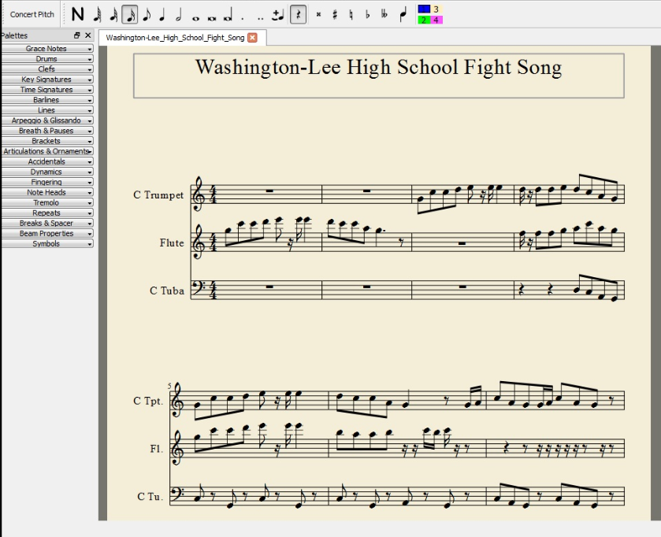

In 2017, I found another interesting use for MuseScore.

My youngest child's high school has for several years offered a crowdsourced choir performance in the annual December choir concerts. It is called Community Choir, and its members are teachers, parents, alumni, and anyone else who wants to sing. No course credit or academic grades are involved, just three evening rehearsals and a performance in front of a big audience, 500+, mostly parents and siblings of current choir students and some families of the Community Choir adults. The school's choir director chooses three songs for the Community Choir to perform. At the first rehearsal, he hands out the sheet music for the volunteer choir to take home.

In December 2017, I volunteered for Community Choir, for several reasons. First, I missed performing music. Second, after all my experiences in school playing piano, clarinet, oboe and guitar, I had not tried singing since elementary school; over the decades I realized that singing was the one skill I missed the most. Finally, my daughter was about to relocate to Georgia with her husband, so it was my last chance to surprise her.

When the director handed out the sheet music, I decided I would do what I had done for most of my K-12 years: take it home and practice. But, unlike with musical instruments, I had no idea how to hit the correct pitch for a note on the page.

This is where MuseScore came in handy.

I transcribed my parts in the sheet music into MuseScore. The first two songs were about 92 measures each, with a lot of repetition that could be realized fairly rapidly through copy & paste. That transcription process alone made me very familiar with the structure of each song. Then I assigned a MuseScore male voice to the notes in each song. I did not include the lyrics. I just wanted to hear the notes, so I could hit them accurately for practice.

MuseScore played each song, and I sang along by reading the lyrics in the original sheet music.
It worked. Practice made me a lot more confident that I could perform the material.

The school is a combined program including grades 6 through 12, and I attended all the concerts while my daughter was a student there during 2004-2011. For most of that time, I led a volunteer team of parents that shot photos, video and recorded audio of the concerts, and made DVDs and audio CDs of the concerts for music department fundraisers. After my daughter graduated, I continued to attend the concerts simply because, with free admission, they are the best entertainment value in town.

The final song was the Hallelujah Chorus from Handel's Messiah. It is both more complicated and more familiar. Roughly 116 measures, I have heard it performed every December at the school since 2004. It too is crowdsourced but on a grander scale. The choir director not only includes the Community Choir and all high school choir students, but also invites all choir alumni/ae to come up and sing, so the group is enormous, literally overflowing the stage.

My first public music performance since 1971 happened on December 19, 2017. It was fun.

This type of practice at home has its limits. I did not transcribe the other voice parts, just the one I was trying to learn. That is important. One of the songs was a round (AKA rondo), where the entrance timing is different for soprano, alto, tenor and bass. Hearing all the parts is useful for practicing the precise rondo entrance points. Likewise, I did not transcribe the accompaniment. For two of the three songs, that was a piano part.

All the parts and the accompaniment were on the sheet music I was given. I was not sure I had time to transcribe all the parts into MuseScore. Maybe next year.

[Please notify author when reprinted.]
John Krout is a former president of WAC, one of the predecessor organizations of PATACS. John lives across the street from a house once occupied by a military family including a young Jim Morrison, who later became the singer for the Doors. One of John's favorite photo subjects is performing musicians. Among those musicians is Jorma Kakounen of Jefferson Airplane and Hot Tuna, who once visited John at home. Jorma graduated from Wilson High School in DC; his dad was a career diplomat.

